**Assignment Data Science**

1. **Group Memebers**

**Syed Mubashir Ali(2k20/ITE/73)**

**Hamza Maqsood(2k20/ITE/47)**

**Huzaifa(2k20/ITE/65)**

**Mujeeb(2k20/ITE/87)**

**Sohail Khan(2k20/ITE/130)**

**One Hot Encoding**

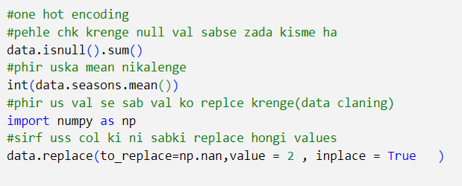

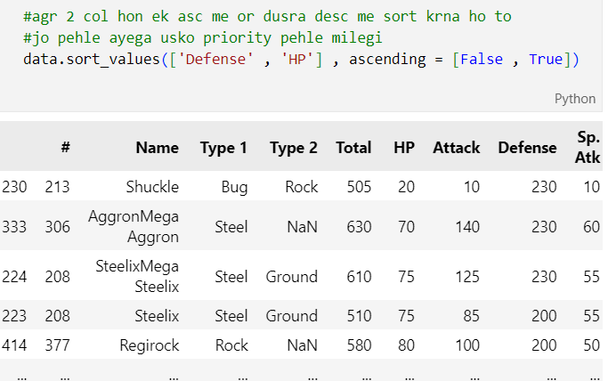

**Feature Engineering**

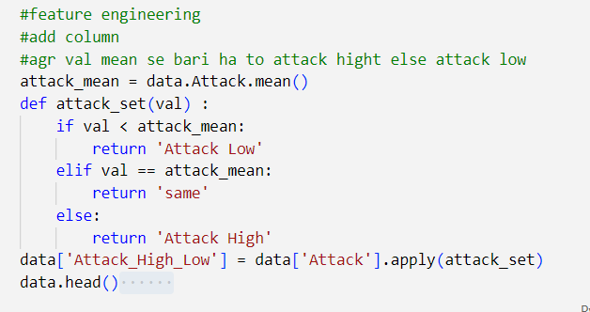

**Konsi cheez kidhar kidhar arhi ha**

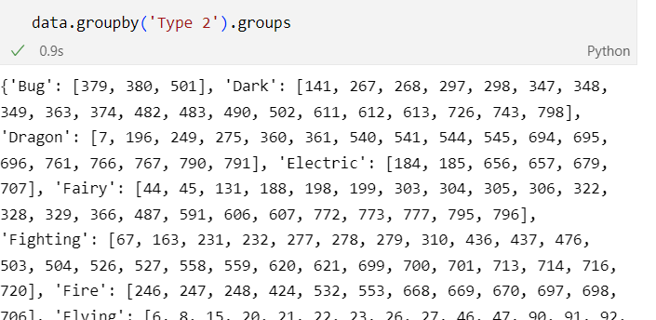

**Agar kisi particular col ki sari rows chahiye hon**



**Agar ek row me bhtt name hain or unka sum chahiye to**

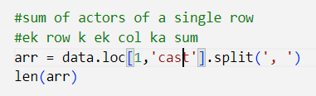

**How to replace values or none values in column (one hot encoding when dt is str)**

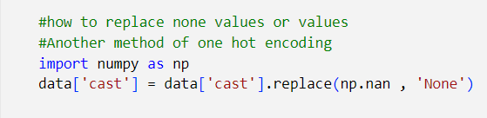

**Agr kisi col k against us col ka kuch particular data chahiye ho to**

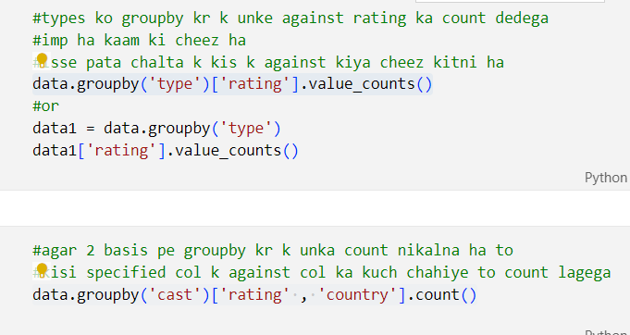

**\*\*\*axis 0 pe index or 1 pe column leta ha \*\*\***

**\*\*\*In drop duplicates rows are same when deleting the rows\*\*\***

**Theory**

